RESOLUTION NO.__________

RE: CERTIFICATE OF APPROPRIATENESS UNDER THE
PROVISIONS OF THE ACT OF THE PENNSYLVANIA
LEGISLATURE 1961, JUNE 13, P.L. 282 (53
SECTION 8004) AND BETHLEHEM ORDINANCE NO.
3952 AS AMENDED.

WHEREAS, it is proposed to replace the existing windows, storm windows and front screen door at 58 E. Wall Street.

NOW, THEREFORE, BE IT RESOLVED by the Council of the City of Bethlehem that a Certificate of Appropriateness is hereby granted for the proposal.

Sponsored by: (s)

(s)

ADOPTED BY COUNCIL THIS DAY OF

(s)
President of Council

ATTEST:

(s)
City Clerk

HISTORICAL & ARCHITECTURAL REVIEW BOARD

APPLICATION #1: The applicant proposes to replace the existing windows and storm window on the first and second floor on both street facades and replace the existing front screen door at 58 E. Wall St.

OWNER: Russell & Mary Jo Miserendino
58 E. Wall St., Bethlehem, PA 18018
__________________________________________________________________

The Board upon motion by Nancy Shelly and seconded by Marsha Fritz adopted the proposal that City Council issue a Certificate of Appropriateness for the following:

- Replace all first and second floor windows on both street facades.

- To be replaced with Andersen Woodwright double hung windows with six over six divided lights finished in white.

3. Install a new wood storm and screen door manufactured by Easy Change.

4. Style of door to be County Side #55 or Traditional #50 with undivided glass and
screen panels on the upper portion and solid wood panel on the bottom.

5. Color of door will be White.

6. The motion was unanimously approved.

__________________________________________________________________________

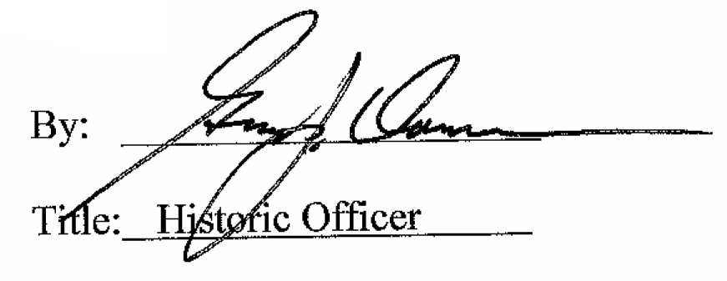

Date of Meeting: February 4, 2015

